THE CINEMATOGRAPHY OF ‘BREAKING BAD’
PART 2 – COMPOSITION
WRITTEN BY BENJAMINKANTOR
cinevenger.com

MASTER SHOTS

“Breaking Bad” is rich in master shots that carry the burden of storytelling weight. This seems typical of television in that the master shots are often relied on to portray the character relationships, while the “coverage” is frequently more standardized and does less in the way of storytelling. I’ve selected some of the master shots that were particularly powerful:

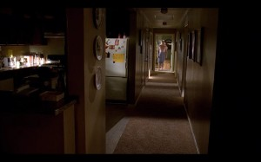

In the scene immediately preceding this one, The Cousins waited for Walt in his bedroom while he showered, intent on killing him when he emerged. Mike contacts Gus to call off the Cousins, leading Walt to unknowingly avoid death, left only with a small clue of their presence by the mysterious displacement of the toy eyeball.
The main compositional feature in this image is the perspective lines created by the hallway which all converge on Walt standing in the doorway. These lines pointed at Walt from all sides give the sense that he has been targeted and is vulnerable.

Simultaneously, the contrast of value, from the bright room at the end of the hall, versus the dark shapes of the hallway, give the sense that Walt is surrounded by unknown dangers. This is accentuated by the contrast of size (created by the wideness of the lens, which disproportionately accentuates the size of close objects versus far objects). Walt is dwarfed by the dark shapes that surround him, making him seem trivial compared to the danger he faces.
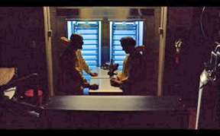
In this scene, Walt and Gale are bonding at the end of their first day. Walt is simultaneously concerned about Gale’s origins, concerned that he may be training Gale as his own eventual replacement.
The symmetry of the composition, accentuated by the pair of matching blue tray stacks, draws a comparison between Walt and Gale, giving a sense of similarity between them. However, the other compositional elements seek to portray comparison negatively by visualizing Walt’s fears: the geometric silhouette that surrounds them constricts them to the center of the frame, tightly boxing them in, giving a sense of claustrophobia, and introducing the idea that the lab may not be big enough for the two of them. This is reinforced by the silhouette between them, which divides their similar backgrounds, seemingly putting them at odds with each other.
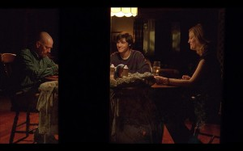

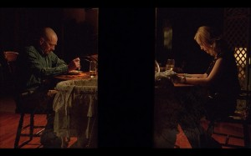

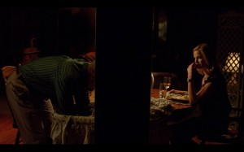
In this scene, Skyler, who has been cheating on Walt with Ted Beneke, is beginning to feel that her affair with Ted feels cold and artificial in contrast to her relationship with her family, despite her hostility towards Walt.
The shot starts with Skyler and Walt Jr. on one side, and then dollies over to the symmetric composition seen in the second image above. Walt then stands and removes Holly from a cradle, partially obscured by the pillar. The use of large column of negative space to divide Walt and Skyler compositionally in the frame is an easily evident way to show them at odds with each other. However, the shot goes deeper: in the initial composition, the negative space pushes Walt off to the side of the frame to accommodate the larger piece occupied by Skyler and Walt Jr, giving a sense of Walt’s growing exclusion from his family.
Once Walt Jr. has exited, the camera dollies over and settles into a symmetric composition, brutally divided by negative space from the pillar, portraying Walt and Skyler now as even forces in the callous battle over their family. Skyler then asks Walt if he would like to take Holly. He then leans into the negative space and pulls the previously obscured Holly from the cradle. As Holly emerges from the negative space into Walt’s side of the frame gives the sense of movement from Skylers side to Walt’s: an olive branch extended from Skyler to Walt.
______________________________________________

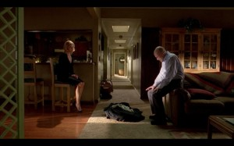

This is a shot I looked at last time from a purely lighting perspective, but it’s also working on a compositional level. In this scene, Walt is attempting to convince Skyler that they should take the money he’s made, put his criminal past behind them, and move forward with their lives together. In this composition, a bright hallway dominates the background of the shot, the distant converging perspective lines holding the potential of a withdrawal from the conflict of the foreground. The bag of money, the literal representation of Walt’s criminal acts, sits immobile, centered between both them and the hallway. The sum of these compositional elements gives the sense that Walt’s actions are an insurmountable obstacle to the two of them escaping the present and moving forward together.

ULTRA WIDE EXTERIOR SHOTS

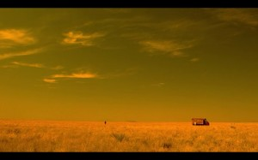

In the previous article, I mentioned my belief that the wide exterior shots in ‘Breaking Bad’ were some of the most memorable images in the series. They work to portray the characters as minuscule relative to their environments, and to reveal the desolate expanse around them. This sense of isolation is used for very basic and straightforward storytelling purposes: In the first image above, the massive barren expanse dwarfs the RV, and informs the audience as to the extremes Walt and Jesse have gone to get away from civilization in order to safely perform their cook.
In the second image, part of a scene in which the Cousins execute an entire truck full of immigrants, the empty expanse fills the entire frame, revealing their extreme isolation, which in turn gives the audience a sense of helplessness as they realize that there’s no chance of outside observation or interference with the brutal and mechanical execution.

UNREALISTIC ANGLES

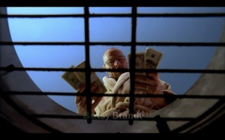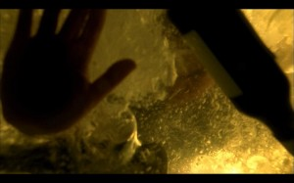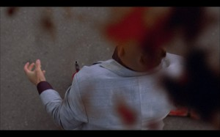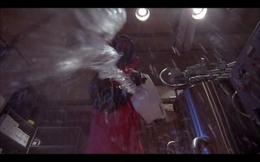

Another recurring feature is unrealistic angles that place the camera inside non-existent surfaces. Materials (such as the blood and other liquids seen left) interacting with this ‘impossible camera’ draw attention to the cameras presence, accomplishing a sense of surrealism. This seems to serve the tone of the show rather than a specific story goal. The shots draw attention to themselves and give an outlandish and fantastic feel to the series, adding a sprinkle of graphic imagery reminiscent of a comic book. This helps paint a world that could be plausibly inhabited by such super-villains as Gus and the Cousins. Another great contributor to this feel is the color palette, which I will examine on the next installment.
_____________________________________________

‘Breaking Bad’ is filled with great master shots, and with five seasons, it’s impossible to find all of them… maybe not even all of the best ones. One of the disadvantages of examining an entire television series is the ability to miss great gems.

