An Introduction to Film Sound
by Jane Knowles Marshall

Though we might think of film as an essentially visual experience, we really cannot afford to underestimate the importance of film sound. A meaningful sound track is often as complicated as the
image on the screen. The entire sound track is comprised of three essential ingredients:
- the human voice
- sound effects
- music
These three tracks must be mixed and balanced so as to produce the necessary emphases which in turn create desired effects. Topics which essentially refer to the three previously mentioned tracks are discussed below. They include dialogue, synchronous and asynchronous sound, and music.
THE HUMAN VOICE: dialogue
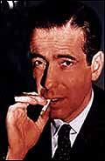
Dialogue authenticates the speaker as an individual or a real person rather than the imaginary creation of a story teller. As is the case with stage drama, dialogue serves to tell the story and
expresses feelings and motivations of characters as well. Often with film characterization the audience perceives little or no difference between the character and the actor. Thus, for example:
Humphrey Bogart is Sam Spade; film personality and life personality seem to merge. Perhaps this is the case because the very texture of a performer's voice supplies an element of character.

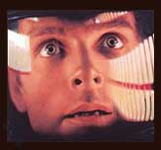
When voice texture fits the performer's physiognomy and gestures, a whole and very realistic persona emerges. The viewer sees not an actor working at his craft, but another human being struggling with life. It is interesting to note that how dialogue is used and the very amount of dialogue used varies widely among films. For example:
In the film 2001 little dialogue was evident, and most of what was used was banal. In this way the filmmaker was able to portray the “inadequacy of human esponses when compared with the magnificent technology created by man] and the visual beauties of the universe.”[2]

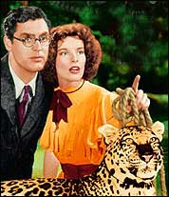
The comedy, Bringing Up Baby, on the other hand, presents practically non-stop dialogue delivered at break-neck speed. This use of dialogue underscores not only the dizzy quality of the character played by Katharine Hepburn, but also the absurd duality of the film itself and thus its humor. The audience is bounced from gag to gag and conversation to conversation; there is no time for audience reflection. The audience is caught up in a whirlwind of activity in simply managing to follow the plot. This film presents pure escapism - largely due to its frenetic dialogue.
SOUND EFFECTS: synchronous and asynchronous sounds
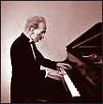
Synchronous sounds are those sounds which are synchronized or matched with what is viewed. For example:
If the film portrays a character playing the piano, the sounds of the piano are projected.

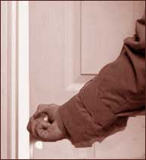
Synchronous sounds contribute to the realism of film and also help to create a particular atmosphere. For example:
The “click” of a door being opened may simply serve to convince the audience that the image portrayed is real, and the audience-may only subconsciously note the expected sound. However, if the “click” of an opening door is part of an ominous action such as a burglary, the sound mixer may call attention to the “click” with an increase in volume; this helps to engage the audience in a moment of suspense.
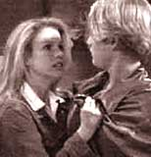
Asynchronous sound effects are not matched with a visible source of the sound on screen. Such sounds are included so as to provide an appropriate emotional nuance, and they may also add to the realism of the film. For example:
A film maker might opt to include the background sound of an ambulance's siren while the foreground sound and image portrays an arguing couple. The asynchronous ambulance siren underscores the psychic injury incurred in the argument; at the same time the noise of the siren adds to the realism of the film by acknowledging the film's (avowed) city setting.

MUSIC: background music
Background music is used to add emotion and rhythm to a film. Usually not meant to be noticeable, it often provides a tone or an emotional attitude toward the story and/or the characters epicted. In addition, background music often foreshadows a change in mood. For example, dissonant music may be used in film to indicate an approaching (but not yet visible) menace or disaster.
Background music may aid viewer understanding by linking scenes. For example, a particular musical theme associated with an individual character or situation may be repeated at various points in a film in order to remind the audience of salient motifs or ideas.
Film sound is comprised of conventions and innovations. We have come to expect an acceleration of music during car chases and creaky doors in horror films. Yet, it is important to note as well that sound is often brilliantly conceived. The effects of sound are often largely subtle and often are noted by only our subconscious minds. Yet, it behooves us to foster an awareness of film sound as well as film space so as to truly appreciate a twentieth century art form, the modern film.
2. Thomas Sobochack and Vivian Sobochack, An Introduction to Film, p.177.

This is an excerpt from America in Film and Fiction
original URL: http://130.132.143.21/ynhti/curriculum/units/1988/4/88.04.04.x.html
This article is a condensed version of several chapters of Sobochack and Sobochack's book, An Introduction to Film. The original web site also contains a section about film space.

